**Google Playstore_Analysis Queries**

**1.Overview of Dataset:**

SELECT

COUNT(DISTINCT APP) AS total_apps,

COUNT(DISTINCT Category) AS total_categories

FROM googleplaystore

**2. Exploring App Categories:**

SELECT TOP 5

Category,

COUNT(App) AS Total_app

FROM googleplaystore

GROUP BY Category

ORDER BY Total_app DESC

**3. Top Rated Free Apps:**

SELECT TOP 10

App,

Category,

Rating,

Reviews

FROM googleplaystore

WHERE Type ='Free' AND Rating <> 'NaN'

ORDER BY Rating DESC

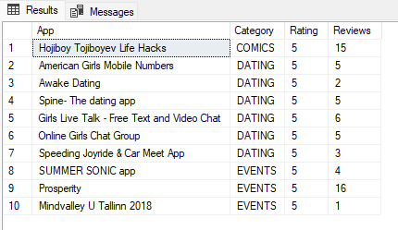

**4. Most Reviewed Apps:**

SELECT TOP 10

Category,

App,

Reviews

From googleplaystore

ORDER BY Reviews DESC

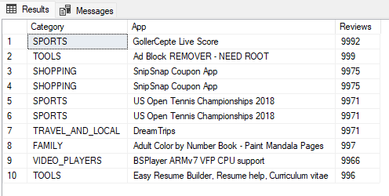

**5. Average Rating by Category:**

SELECT TOP 5

Category,

AVG(TRY_CAST(Rating AS FLOAT)) AS avg_rating

FROM googleplaystore

GROUP BY Category

ORDER BY avg_rating DESC

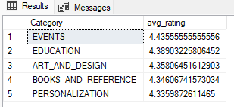

**6. Top Categories by Number of Installs:**

SELECT TOP 10

Category,

SUM(CAST(REPLACE(SUBSTRING(Installs, 1, PATINDEX('%[^0-9]%', Installs + ' ') - 1), ',' , ' ') AS INT)) AS total_installs

FROM googleplaystore

GROUP BY Category

ORDER BY total_installs DESC

**7. Average Sentiment Polarity by App Category:**

SELECT TOP 10

Category,

AVG(TRY_CAST(Sentiment_Polarity AS FLOAT)) AS avg_sentiment_polarity

FROM googleplaystore

JOIN googleplaystore_user_reviews

ON googleplaystore.App = googleplaystore_user_reviews.App

GROUP BY Category

ORDER BY avg_sentiment_polarity DESC

**8. Sentiment Reviews by App Category:**

SELECT TOP 10

Category,

Sentiment,

COUNT(*) AS total_sentiment

FROM googleplaystore

JOIN googleplaystore_user_reviews

ON googleplaystore.App = googleplaystore_user_reviews.App

WHERE Sentiment <> 'nan'

GROUP BY Category, Sentiment

ORDER BY total_sentiment DESC

